

Communication

Date | 15 March 2026
Team ID | NEHAL YADAV
Project Name | FORMULA 1 Race Intelligence Dashboard Analysis Report 2010-2026
Maximum Marks | 1 Mark

Communication Plan:
Effective communication is essential for a successful project demonstration. This document outlines the communication strategy used within the team and with stakeholders throughout the project lifecycle, including how updates, issues, and feedback were managed.

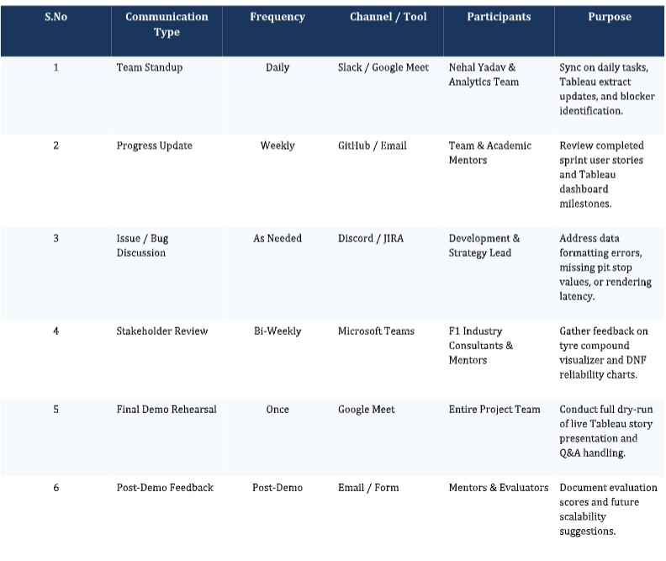

Communication Challenges & Resolutions:

